* [**How to change the look**](https://sharepoint.rackspace.com/learning/articles/Pages/SharePoint-2013--how-to-change-the-look.aspx)

1. From the home page of your SharePoint site, in the upper right hand corner click the site settings **Gear**.

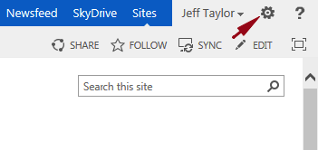

2. From the drop-down select **Site Settings**.

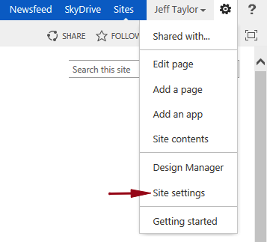

3. On the Site Settings page under Look and Feel click **Change the look**.  
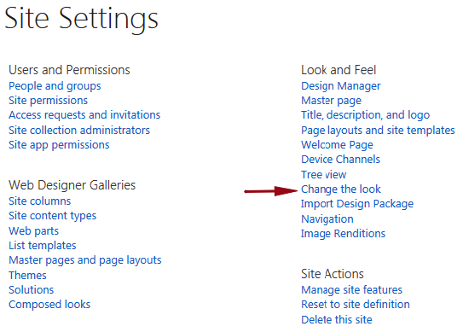

4. Select the Theme you would like, in this example I will click **Sea Monster**.

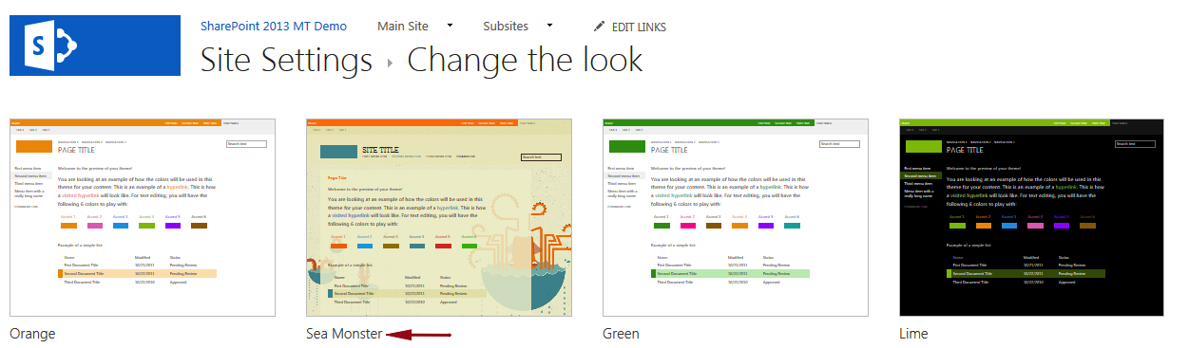

5. You will now be able to edit various aspects of the theme such as Image, Colors, Site layout and Fonts.  For this example I will change the color and font.

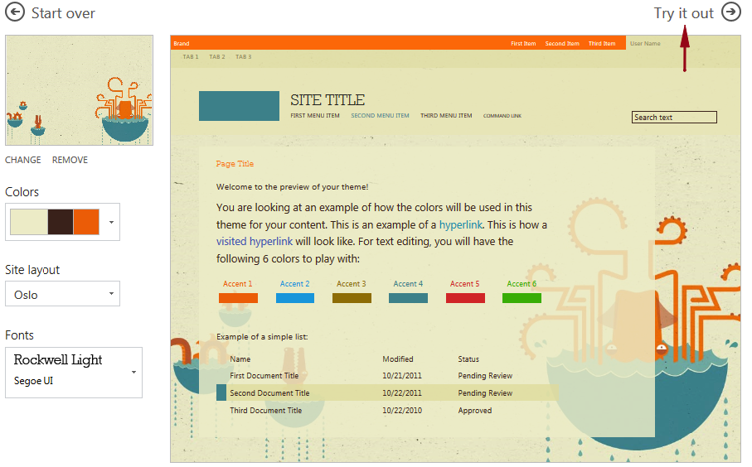

6. To change the colors click the **drop-down arrow** under Colors and **select a new color**.

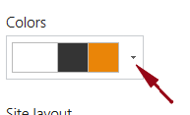

7. To change the fonts, click the **drop-down** under Fonts and **select a new font**.

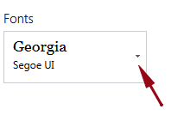

8. Click **Try it out**.

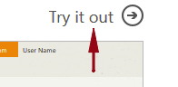

9. A preview of your site will be displayed, if you like how it looks click **Yes, keep it**.  
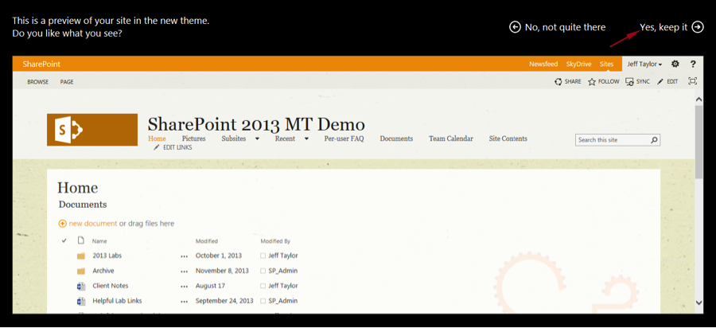

10. Navigate back to your home page and check out the new look.  
